**Cloudera upgrade**

**Prerequisites:**

1. Make sure all CM Agents are communicating with CM Server by running Host Inspector before CM upgrade. This should be done from Cloudera Manager UI.

Click on **Hosts -> Inspect Hosts in Cluster**

Click on **Download Results Data** to save the results to disk.

1. Ensure all services are running in the Cluster without any issues
2. Get all custom jars from all tools like Sqoop, Pig & Hive from /var/lib/ to not fail jobs after upgrade.
3. Make a note of any nodes to down/bring them up before upgrade if possible.
4. Make sure enough space under RPM directory for new CDH Parcels and copy the Parcels

At the time of upgrade process:

1. Send Communication mail to all developers & business users about downtime window.
2. Run FSCK

**clush -g all -b "sudo mkdir /var/www/html/upgrade_backups"  
clush -g all -b "sudo chmod 777 /var/www/html/upgrade_backups"**

Run all in NameNode machine,

**sudo -u hdfs hdfs fsck / -files -blocks -locations -racks > /var/www/html/upgrade_backups/dfs-fsck-old.txt**

1. Get Cluster Status Report

**sudo -u hdfs hdfs dfsadmin -report > /var/www/html/upgrade_backups/dfs-report-old.txt**

1. Get All Files Report on HDFS

**sudo -u hdfs hdfs dfs -ls -R / > /var/www/html/upgrade_backups/dfs-lsr-old.txt**

1. Take screenshot for CM, NameNode, Hive, Yarn, etc., for future reference
2. Stop cluster and Management services
3. Backup all MySQL databases (Hive Metastore, Oozie, Hue, Sentry, scm)

**sudo mysqldump -h cmg.hadoop.com -u root -pwelcome1 --all-databases --add-drop-database --add-drop-table > /var/www/html/upgrade_backups/mysql-backup.sql**

1. NameNode Metadata Directory backup

**clush -g nn -b "sudo mkdir -p /var/www/html/upgrade_backups/nn_data"**

**clush -g nn -b "sudo cp -p -r /mnt/disk1 /var/www/html/upgrade_backups/nn_data"**

This includes fsimage and journal nodes data.

1. DataNode VERSION file back up

**clush -g dn -b "sudo mkdir -p /var/www/html/upgrade_backups/dn_data"  
clush -g dn -b "sudo cp -p /mnt/disk1/data/current/VERSION /var/www/html/upgrade_backups/"**

1. Zookeeper Data Backup

**clush -g zk -b "sudo cp -p -r /var/lib/zookeeper /var/www/html/upgrade_backups"**

1. Perform the upgrade for CM and CDH

**clush -g cmg "sudo /usr/sbin/service cloudera-scm-server stop"  
clush -g hadoop -b "sudo /usr/sbin/service cloudera-scm-agent stop"  
clush -g cmg "sudo tar --same-owner -zcvf /var/www/html/upgrade_backups/etc-cloudera-scm-server.tar.gz /etc/cloudera-scm-server"  
clush -g cmg "sudo tar --same-owner -zcvf /var/www/html/upgrade_backups/etc-default-cloudera-scm-agent.tar.gz /etc/default/cloudera-scm-server"  
clush -g hadoop -b "sudo tar --same-owner -zcvf /var/www/html/upgrade_backups/cloudera-scm-agent.tar.gz /etc/cloudera-scm-agent"**

Copy Cloudera new version parcels to **/var/www/html** directory.

Remove any other repos if we have.

**clush -ab "sudo mkdir -p /etc/yum.repos.d/baserepos"**

**clush -ab "sudo mv -f /etc/yum.repos.d/* /etc/yum.repos.d/baserepos/"**

**clush -ab "sudo ls /etc/yum.repos.d/"**

Create new repo file.

**ls -l /var/www/html/cloudera-cdh5.12.0  
sudo createrepo /var/www/html/cloudera-cdh5.12.0 -o /var/www/html/cloudera-cdh5.12.0**

Create cloudera-cdh5.12.0.repo:

**sudo vi /etc/yum.repos.d/cloudera-cdh5.12.0.repo**

add below content to the file:

**[cloudera-cdh5.12.0.repo]**

**enabled = 1**

**name = "My Local Repository for Hadoop"**

**baseurl = http://192.168.56.111/cloudera-cdh5.12.0/**

**gpgcheck = 0**

Clean old Repos

**sudo yum clean all**

Upgrade CM UI

**sudo yum upgrade -y cloudera-manager-server cloudera-manager-daemons**

Start CM Server & Agents (In CM Node)

**sudo service cloudera-scm-server start**

This will start CM with MySQL. To see the logs,

**sudo ls -ltr /var/log/cloudera-manager-installer  
sudo tailf /var/log/cloudera-scm-server/cloudera-scm-server.log**

Login to CM Server UI.

[**http://192.168.56.111:7180**](http://192.168.56.111:7180)

**username: admin  
password: admin**

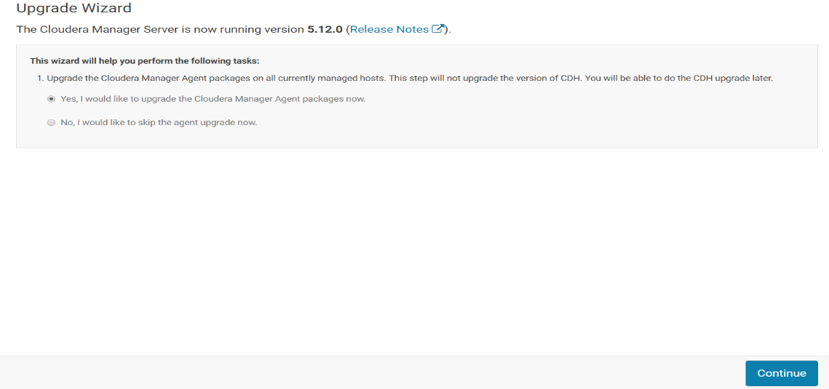

Use Custom Repository option and enter below URL.

Custom Repository Location:

**http://192.168.56.111/cloudera-cdh5.12.0/**

Custom GPG Key URL:

**http://192.168.56.111/cloudera-cdh5.12.0/RPM-GPG-KEY-cloudera**

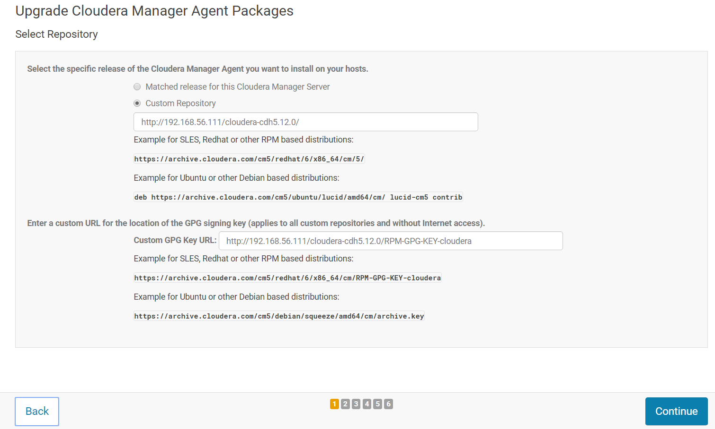

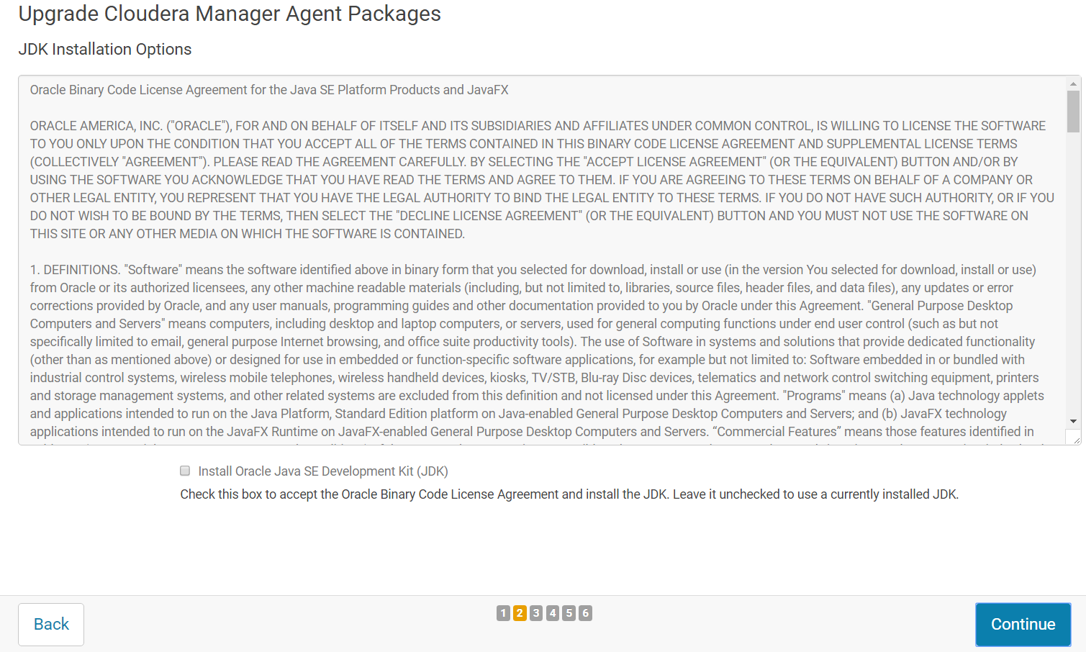

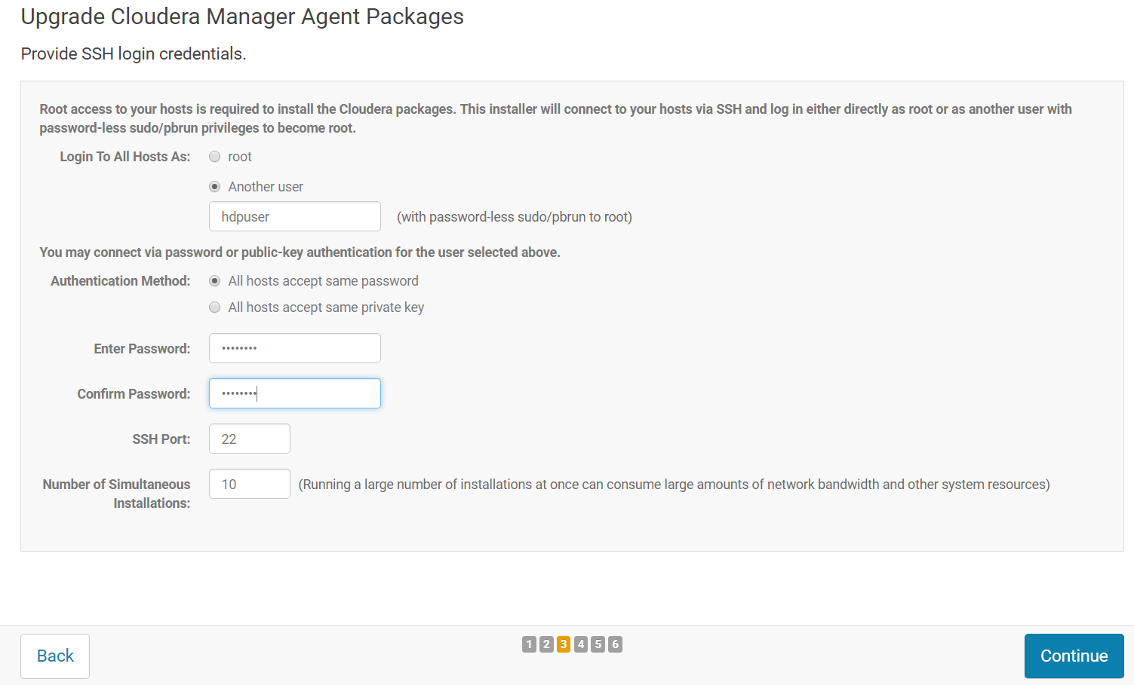

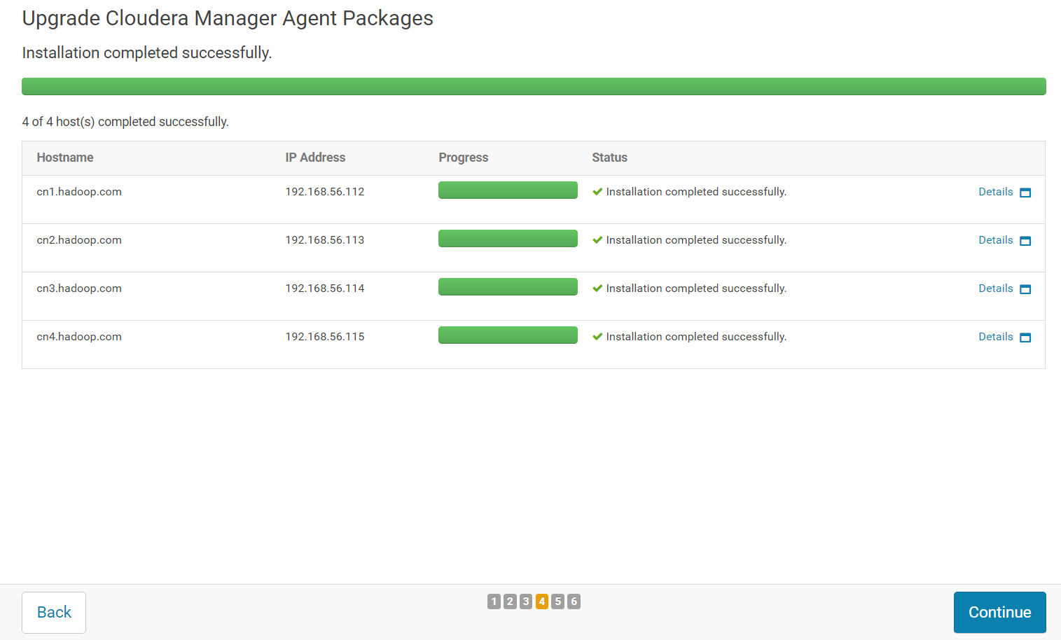

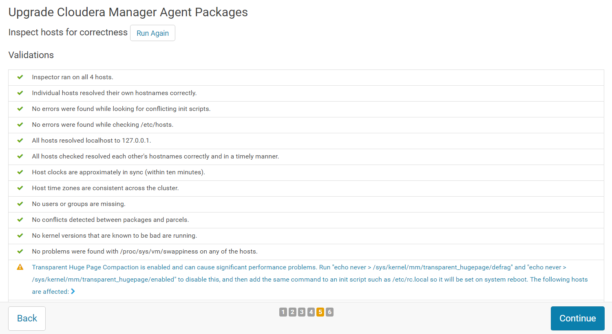

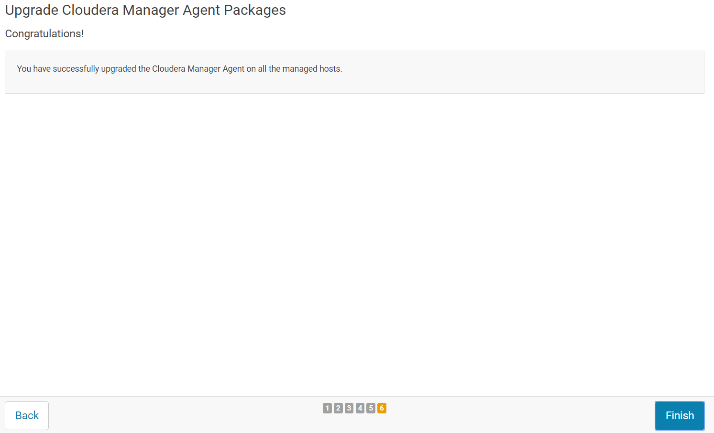

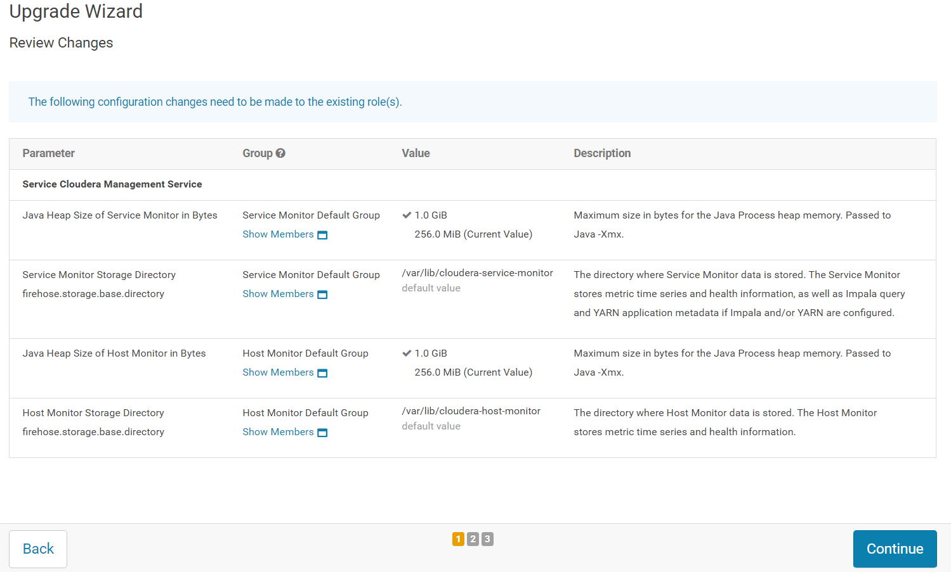

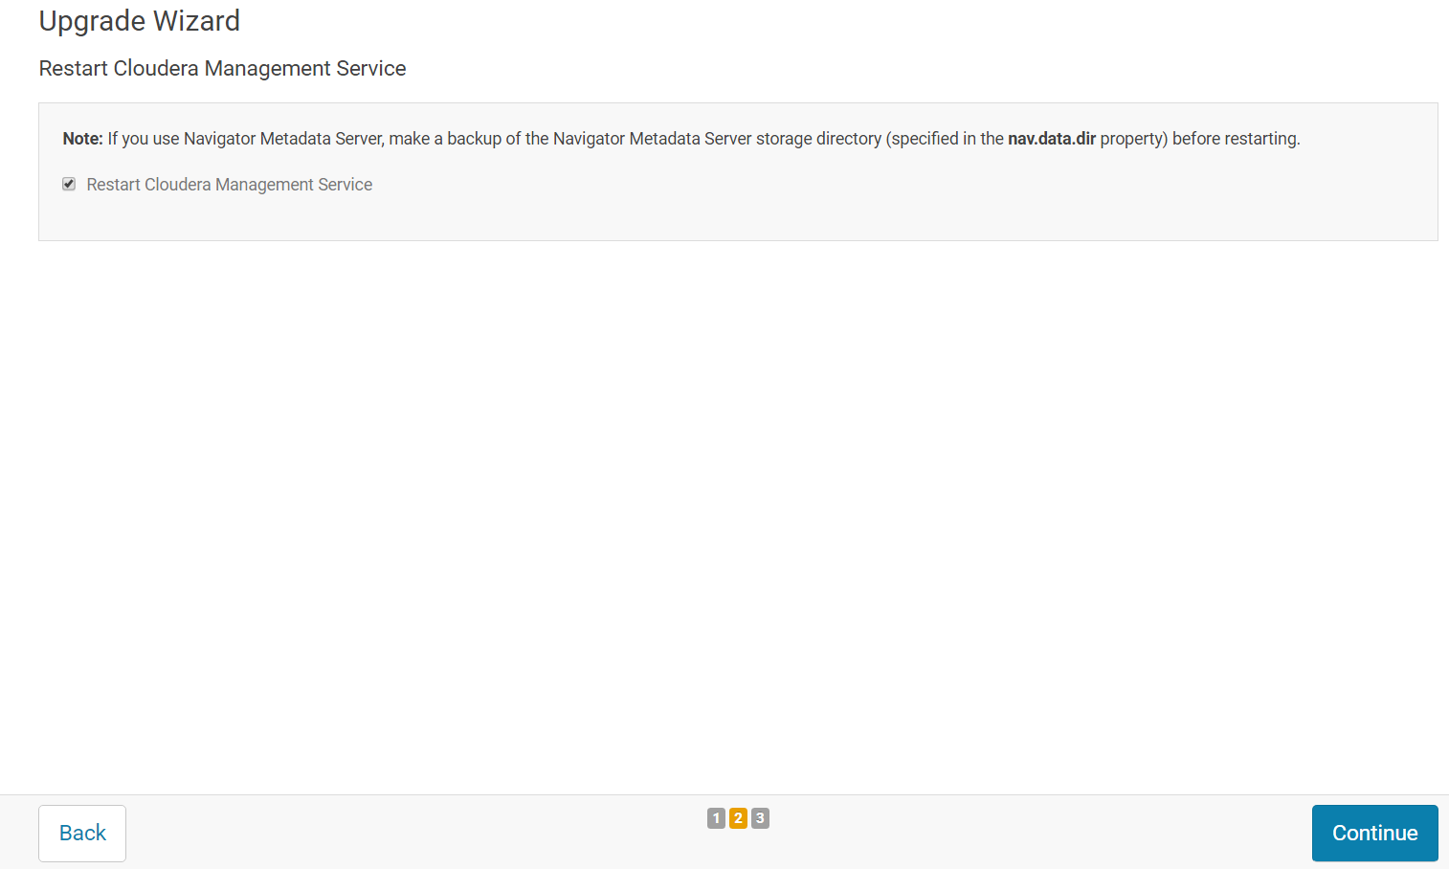

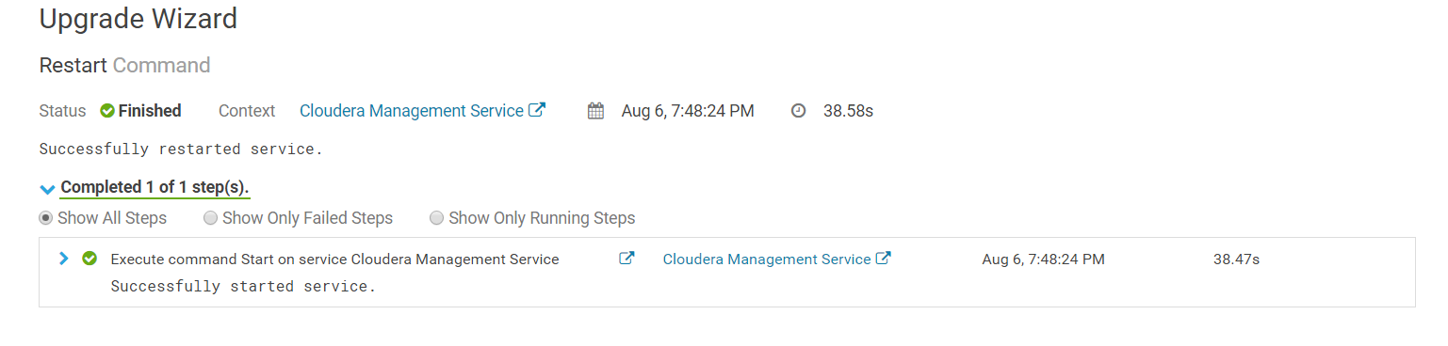

Check your new CM Version

Support -> About

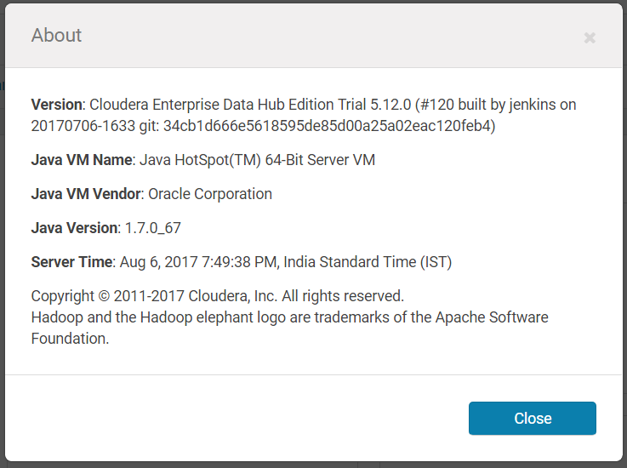

Point your CM to new parcel location.

Click on Parcel symbol on top right corner and click on “Configuration”. Delete all existing parcel locations and add custom repository location. Click on “Save Changes” and click on “Check for New Parcels”

